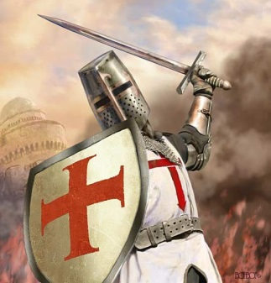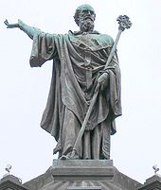[](http://en.wikipedia.org/wiki/File:StatueUrbanII.jpg)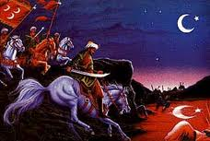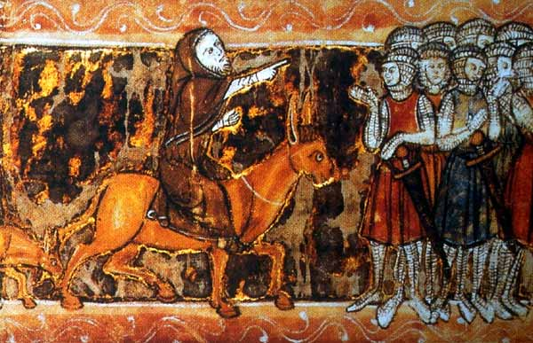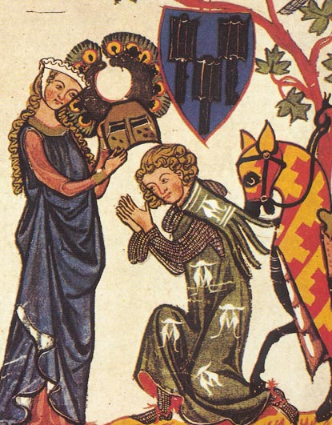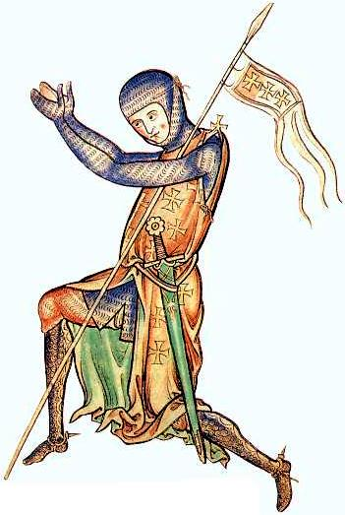

**CARD 15: It is the will of God**

Thousands put the cross on their clothes as a pledge of their sacred and holy mission to go forth and rescue the Holy Land. People in Europe believed in God and believed God wanted the Holy Land controlled by the Christians.

**CARD 14: Pope Urban II**

The first Pope to call for a Crusade: *"God wills it! God wills it! Let these words be your war-cry when you meet the enemy,"* said the Pope.

**CARD 13: Turkish Threat**

The Turks were making advances and even threatening Constantinople and the Byzantine Empire. Many pilgrims were persecuted and could no longer go on pilgrimage to the Holy places.

**CARD 12: Peter the Hermit**

After the bloody massacre of his peoples Crusade which had been a peaceful pilgrimage of poor civilians Peter helped lead and organise the First Crusade. He preached from his donkey encouraging many to go on Crusade.

**CARD 11: Knighthood and Chivalry**

Knights wanted to prove themselves in battle and especially those that were not first born wanted land, power and titles.

**CARD 10: Religious Conviction**

Crusaders were Christian and saw going to the Holy Land as a pilgrimage which would forgive them their sins and help their souls into Heaven. Dying would make them martyrs and killing non-believers was viewed positively.